Introduction to Cloud Computing
Subject: Introduction to Cloud Computing
Credit: 2

Unit 1: Understanding Cloud Computing
Date: 09/07/2026 – Lecture 1
Objectives
After studying this unit, students should be able to:
- Define Cloud Computing.
- Explain the need for Cloud Computing.
- Describe the evolution of Cloud Computing.
- Explain the characteristics of Cloud Computing.
- Discuss the benefits and challenges of Cloud Computing.
- Identify real-world applications of Cloud Computing.

Traditional Computing
In traditional computing, all resources are managed locally.
Features
- Software is installed on the local computer.
- Data is stored on the local hard disk.
- Limited storage capacity.
- High maintenance cost.
- Hardware purchase is required.
- Software updates must be done manually.
- Difficult to scale when demand increases.

Limitations
- Expensive infrastructure.
- Risk of data loss due to hardware failure.
- Limited accessibility.
- Higher electricity and maintenance costs.

Cloud Computing
Definition
Cloud Computing is the on-demand delivery of computing services such as servers, storage, databases, networking, software, analytics, and intelligence over the Internet, with pay-as-you-go pricing.

Keywords
- Internet
- On-Demand
- Pay-as-you-go
- Scalable

Cloud Computing Architecture

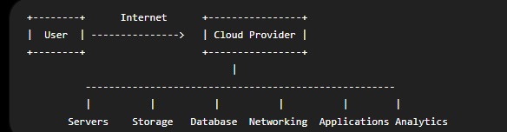

Need for Cloud Computing
Cloud Computing is needed because:
- Reduces infrastructure cost.
- Anywhere access.
- Unlimited storage.
- Easy backup and recovery.
- Supports business growth through scalability.
- Reduces maintenance efforts.
- Provides high availability.
- Automatic Backup
- Virtualization

Question: - Traditional Computing vs Cloud Computing

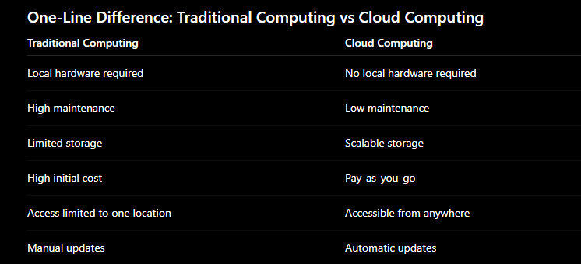

Evolution of Cloud Computing
- Mainframe Computing (1960s) – One computer shared by multiple users.
Example: IBM Mainframe
- Personal Computing (1980s) – One personal computer for one user.
Example: IBM PC, Apple Macintosh
- Client-Server Computing (1990s) – Clients access data and services from a central server.
Example: Bank ATM system, Office LAN
- Internet Computing (2000s) – Applications and services accessed through the Internet.
Example: Gmail, Yahoo Mail
- Cloud Computing (Present) – On-demand computing services over the Internet.
Example: AWS, Google Drive, Microsoft Azure

- Personal Computing → One computer, one user.
- Client-Server → Many clients connect to one server.
- Distributed Computing → Many computers cooperate.
- Parallel Computing → Many processors work at the same time.
- Grid Computing → Computers from different places share resources.
- Cluster Computing → Computers in one location work as a single system.
- Utility Computing → Pay only for the computing resources you use.
- Internet Computing → Services available through the Internet.
- Cloud Computing → Scalable, on-demand services over the Internet with pay-as-you-go pricing.

